Was Malthus Right?
The big question
Will the Earth be able to support roughly 10 billion people -- the 2050 population now predicted by leading authorities? Perhaps.
Robert Thomas Malthus, the political economist who started the overpopulation debate 201 years ago, would have been shocked to see us feeding six billion today (don't forget, however, that more than 800 million people -- about the world's population when he was writing -- get too little to eat).
Still, Malthus's idea was influential, among the "neo-Malthusians." His intellectual heirs include Stanford University biologist Paul Ehrlich, author of the Population Bomb, and Lester Brown, president of Worldwatch Institute.
Glass is half empty
Brown, for example, argues that Malthus made some critical points, but missed two important points: the gains in land productivity (grain production per hectare doubled between 1950 and 1990, he points out), and the preference for eating "higher up the food chain." Instead of eating grain directly, rich countries prefer feeding it to animals. That produces more-desirable food, but uses a lot more grain.
In general, the neo-Malthusians think Malthus was right -- but perhaps ahead of his time. In sub-Saharan Africa, where drought, poverty, and a shortage of arable land all limit food production, and AIDS is reducing life expectancy, however, some could argue that Malthus is being proven correct -- on a regional scale -- right now. Life expectancy in Kenya -- 56 before the AIDS epidemic -- is expected to plunge to 42 by 2010 (see "AIDS to Reduce... " in the bibliography). Botswana, where one-quarter of adults are infected with HIV, is suffering a similar fate.
Globally, the scarcity of fresh water is the most compelling reason to worry about food supplies. "It's probably the most underestimated resource limitation the world is facing," says Brown. "Very few countries, other than China, have tried to take water supplies into account in formulating their population policies."
India, Brown points out, is in particularly dire straits regarding water. A new study by the International Water Management Institute found that India is drawing underground water at twice the rate of recharge. Since 55 percent of India's food comes from irrigated land, and more than half of its children are under-nourished or mal-nourished, Brown says, if the study is "at all close to the mark, India is in trouble."
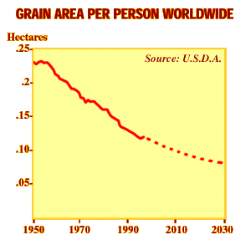
The neo-Malthusians point out that:
- Fish are growing scarce in the oceans.
- Worldwide, the amount of farmland per person is steadily declining.
- Global warming could interfere with food supplies in unpredictable ways.
- The Green Revolution, which enabled India and other countries to feed themselves, has slowed. Grain production per hectare has risen at only 1 percent since 1990 after rising at twice that rate for the previous 40 years. Funding is stagnant for the international agriculture research that sparked the Green Revolution. "People in the northern countries think we've solved our agriculture problem, and we don't have to worry," says Barbara Rose, director of Future Harvest, an institute that promotes funding for this research. "We say we need to worry. Eighty million people will be born each year well into the next century, mostly in developing countries."
- Ten billion people could wreak huge ecological consequences in terms of resource depletion, biodiversity loss and the destruction of wilderness (see "A Special Moment..." in the bibliography).
All this gloom and doom is anathema to those who believe that more people translates not into more misery, but into more ingenuity and more solutions to human problems. These so-called cornucopians were exemplified by the late University of Maryland professor of business administration Julian Simon.
No, it's half full!
Not all cornucopians believe, as Simon did, that there's no practical limit to growth, but in general they feel that the limit is not in sight. Here are some of their arguments:
- Food production is still growing, and prices are falling. According to Rose, research and science will enable us to feed more billions. We have the ingenuity -- if not the funding.
- Malnutrition and starvation reflect political incompetence or war, not problems with the food supply.
- Material prices are dropping, indicating ever-increasing supply. Technology -- think of the information revolution -- continually allows us to do more with less.
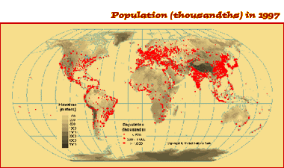
So how many people can the Earth feed? In a 1995 book on the issue, demographer Joel Cohen found a huge range of estimates -- from one billion to one trillion (!) (see "How Many People... " in the bibliography). One trillion might be a trifle crowded, but Most of the estimates were between 4 and 16 billion, indicating that we have already entered the zone of limits.
And the glass actually is...
Sorry. The Why Files is not going to tell you what to think about an ancient debate between economics and ecology, but we do think the biologists have a point: Unlimited population growth is impossible. Eventually, starvation, disease or another factor (like war or chaos) will reverse the trend. The world, as demographer Carl Haub of the Population Reference Bureau notes, is dividing into two demographic zones. Population in developed countries is stabilizing. Most population growth is occurring in places that already have trouble feeding their people.
And that, in the long term, could make quite a problem. "I think that if fertility does not come down in the developing countries, we may not get out of this mess," says Haub. "People in Europe may go on as if nothing had happened," he adds, but if population continues soaring in sub-Saharan Africa and South Asia, in "countries where poverty is truly rampant, there will be a lot of starvation."

PRINT THIS PAGE
DIRECTIONS: Fill in the chart to compare/contrast population theories
Thomas Malthus | Neo-Malthusians | Critics

ANSWER THE FOLLOWING FRQ PROMPT ON A SEPARATE PIECE OF PAPER (Can be typed)
- In 1798 Thomas Malthus published An Essay on the Principles of Population in which he argued that population growth will inevitably outpace food production, resulting in widespread famine.
  - Identify and explain TWO reasons why some geographers today believe Malthus’ theory can be used to predict future population issues
  - Identify and explain TWO reasons why some geographers today believe Malthus’ theory cannot be used to predict future population issues.

